**Engineering Studies ATAR**

# **Year 11**

# **Unit 1 Theory**

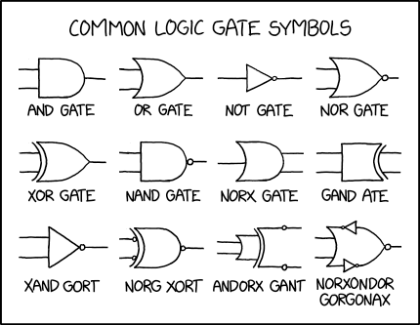

(Munroe, Logic Gates, 2021)

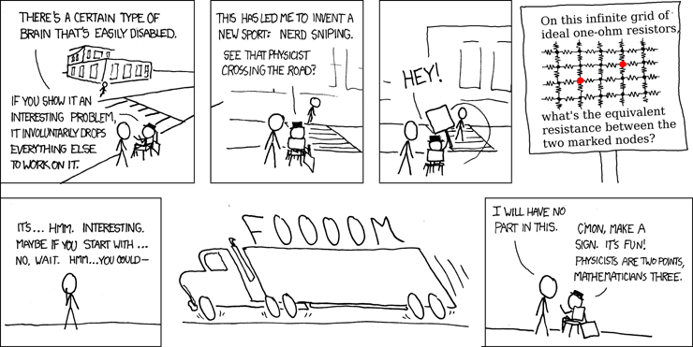

(Munroe, 2007)

**Name:__________________________**

****Disclaimer****

*This text has been developed to assist both teachers and students in meeting the required Outcomes for Year 11 Engineering Studies ATAR. Although the information presented in this resource was accurate to the best of their knowledge at the time of issue, the author/s cannot guarantee that every statement is correct or without error of any kind.*

*The author/s therefore, disclaim liability for any errors, omissions, loss or any other consequence resulting from any individual relying or acting upon any information provided in this resource.*

*Although every effort has been made to trace the sources of information used in the preparation of this book, if we have not acknowledged adequately any person to their satisfaction, please inform Kennedy Baptist College (*[*admin@kennedy.wa.edu.au*](mailto:admin@kennedy.wa.edu.au)*) and the matter will be rectified in any further editions or published works for this course in the future.*

# **Unit 1**

## **Drawing**

#### Pictorial

Pictorial drawings in engineering attempt to show the 3D structure of the object with one view. They are typically drawn using, perspective, isometric or oblique drawing styles.

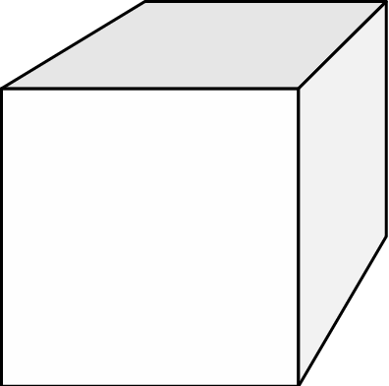Perspective: most realistic view of an object, features closer to the viewer   
appear larger, parallel lines converge into the distance.

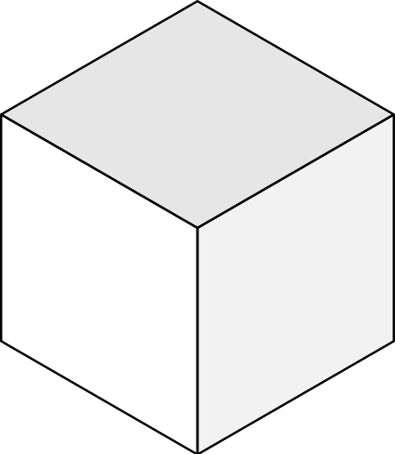

Isometric: most common, parallel lines remain parallel, lengths on the   
three major axes are to scale.

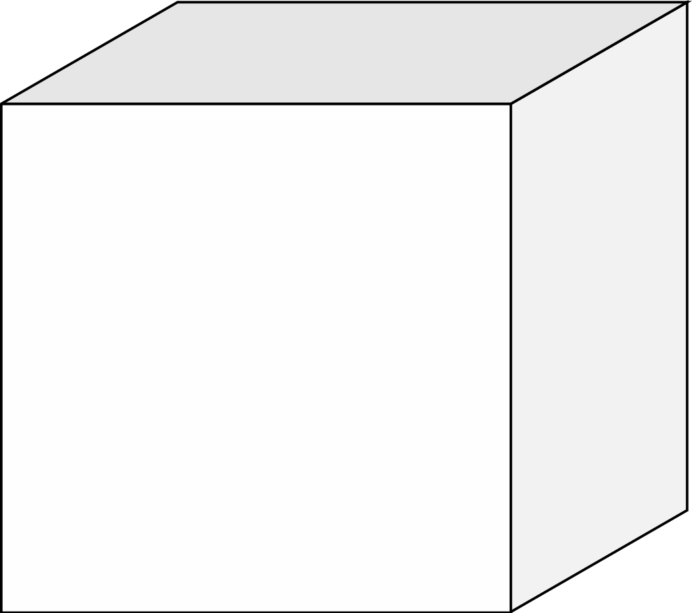

Oblique: parallel lines remain parallel, lengths on two major axes are   
to scale, third axis can be off by a scale factor.

#### Orthographic

Orthographic drawing in engineering shows objects from multiple sides so that the 3D structure of the object can be understood.

There are two common options for laying out the multiple views, first angle projection, and third angle projection. Third angle projection is more intuitive and more commonly used so it is used for this course.

In third angle projection orthographic drawings, the view from the right is drawn on the right, the view from the left on the left, the view from above drawn above and the view from below drawn below.

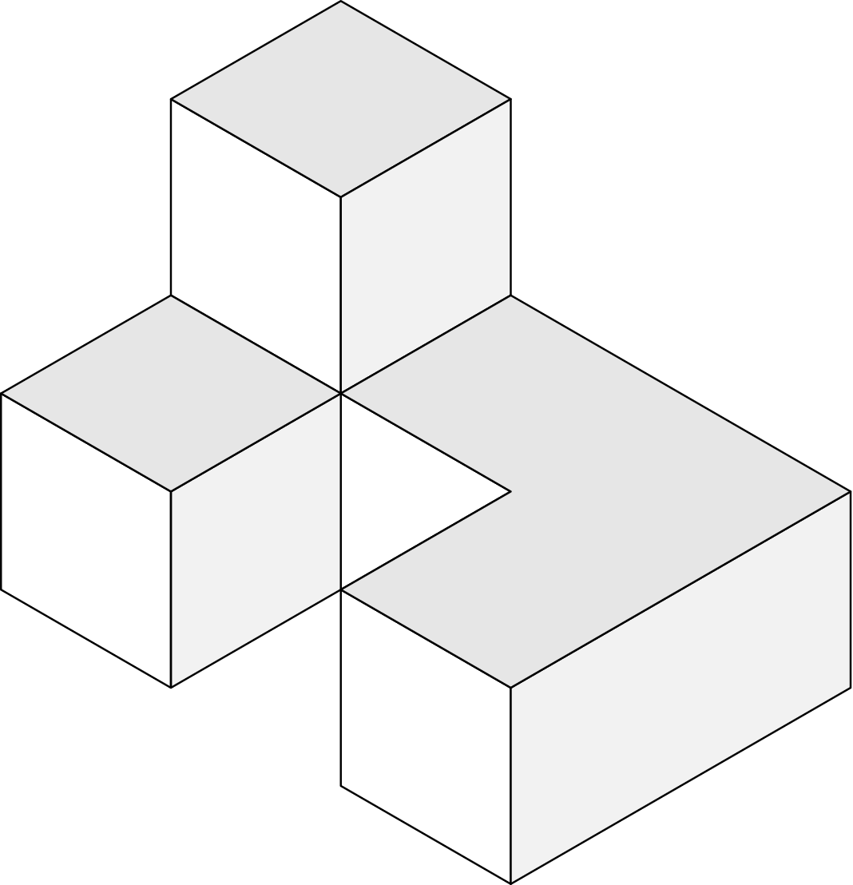

Third angle projection symbol

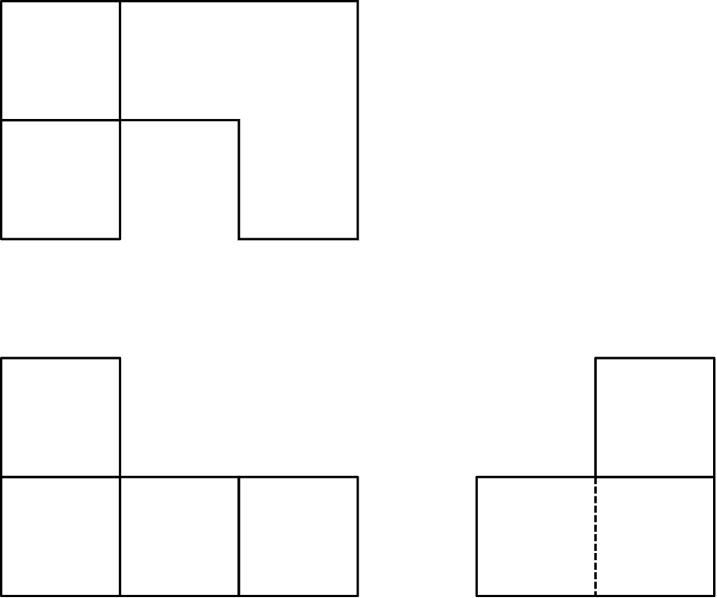

Orthographic drawings should include:

* outlines – solid lines
* hidden detail lines – dashed lines
* centrelines – chain lines

#### Dimensioning orthographic drawings

When orthographic drawings are to be used for construction, they must be dimensioned. This involves adding additional lines to clearly indicate all necessary dimensions.

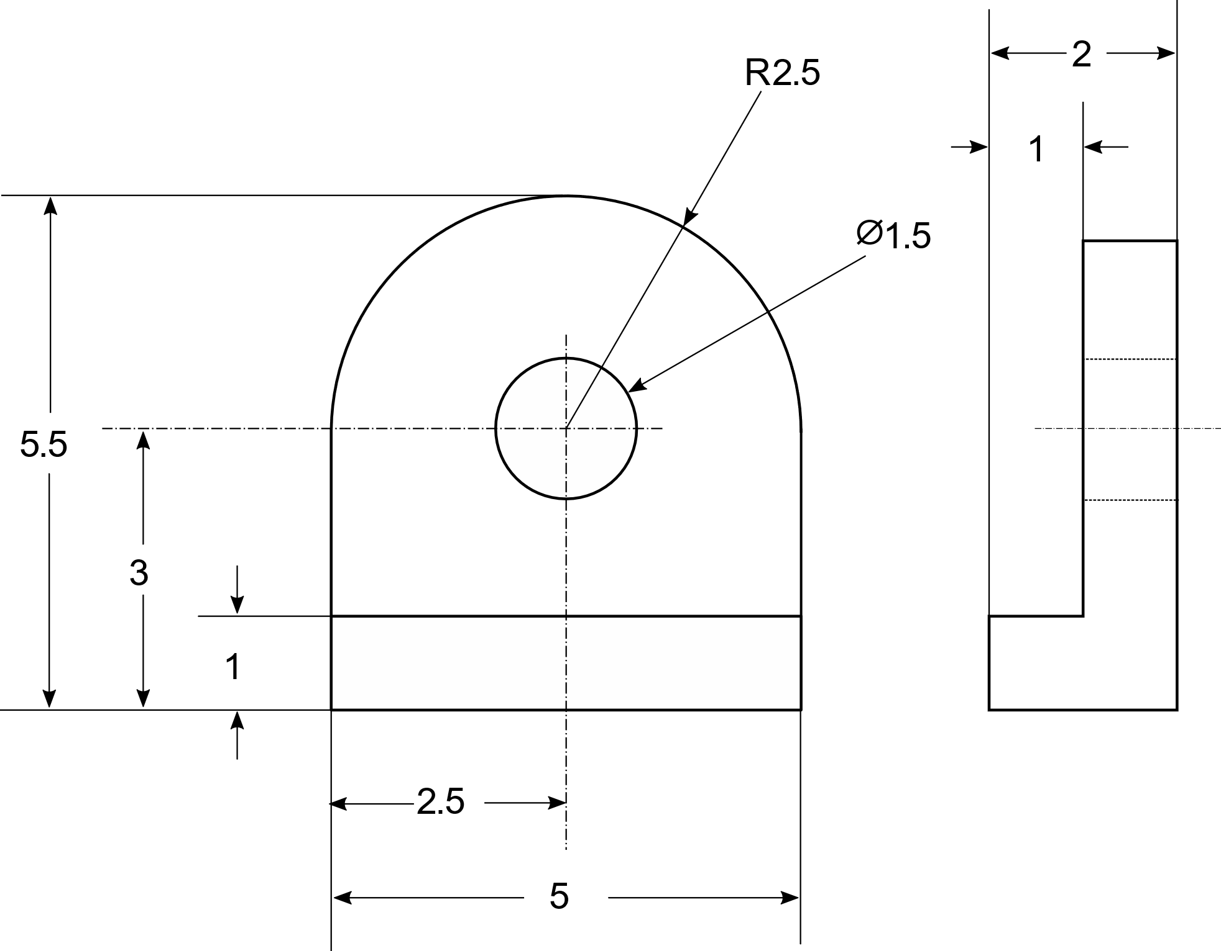

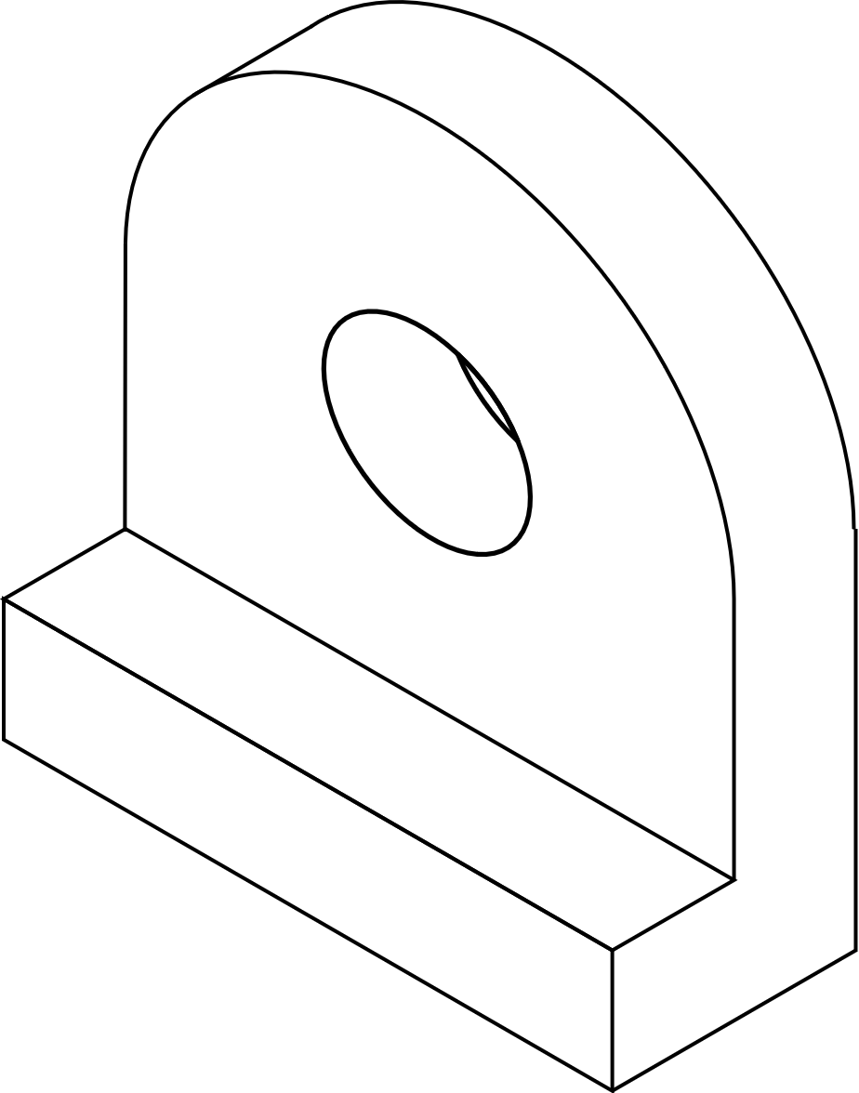

**Note the following points in the example above.**

* **outline lines are thicker than other lines**
* **extension lines extended away from object**
* **dimension lines drawn between extension lines/centrelines**
* **extension lines do not cross centrelines**
* **dimensions written in the middle of dimension lines, typically without units**
* **circles labelled with diameter using a leader line that touches the circle and points towards the centre of the circle, coming away at a 30-60º angle, using the diameter symbol (**⌀)
* **arcs labelled with radius, using a leader line that the touches the arc and points towards the centre of the arc, coming away at a 30-60º angle, using R**
* **dimensions evenly spaced and not written over the shape**
* **each view lines up with the others**
* **no repetition of dimensions**

**Scale can be indicated if the question requires, e.g., 1 cm = 4 cm**

#### **Practice problems (past ATAR exam questions)**

1. **Use isometric grid paper to produce a pictorial drawing of this fitting. Use a ruler for straight lines and a compass or freehand for the circular features.**

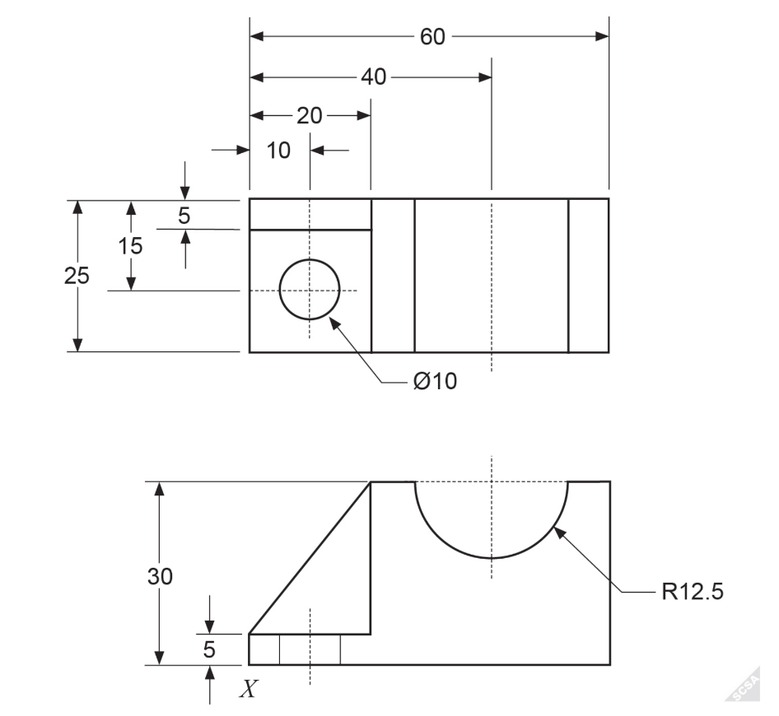

(School Curriculum and Standards Authority of Western Australia, 2019)

1. **Produce a fully dimensioned pictorial drawing of this fitting. Use a ruler for straight lines and a compass or freehand for the circular features.**

(School Curriculum and Standards Authority of Western Australia, 2018)

1. **Use graph paper to produce a labelled 3rd angle orthographic projection of this fitting, showing the front and top views using the correct conventions for line types. You are also required to dimension both views fully. Use a ruler for straight lines and use a compass or freehand for the circular features.**

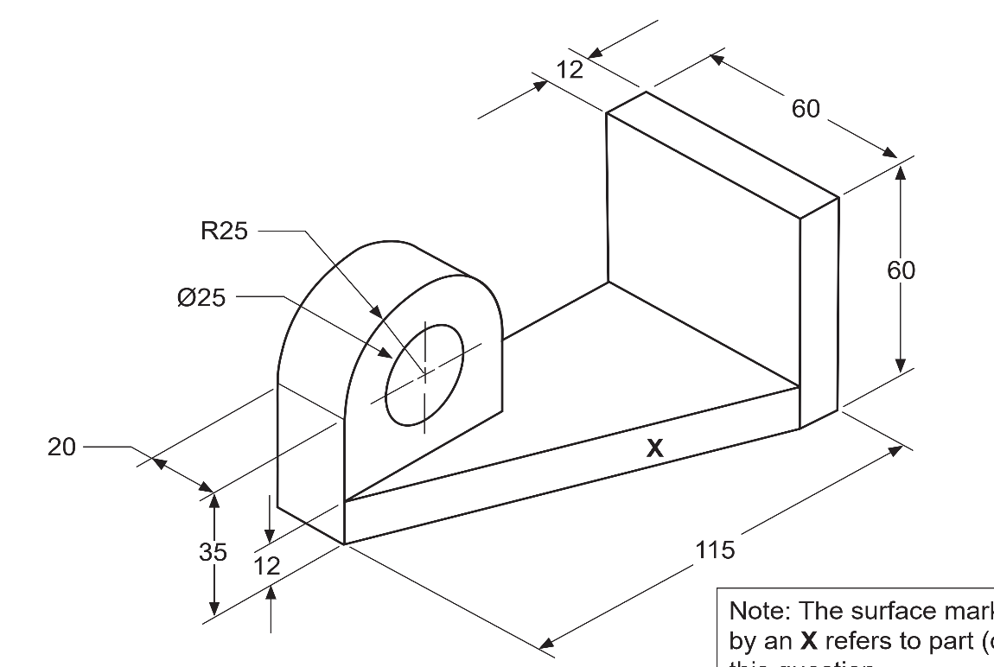

(School Curriculum and Standards Authority of Western Australia, 2020)

1. **Use graph paper to produce a labelled 3rd angle orthographic projection of this fitting, showing the left, right and top views using the correct conventions for line types. You are also required to dimension the diagram fully. Use a ruler for straight lines and use a compass or freehand for the circular features.**

(School Curriculum and Standard Authority of Western Australia, 2017)

1. Diagram, engineering drawing

   Description automatically generated**Use graph paper to produce a labelled 3rd angle orthographic projection of this fitting, showing the front and side views using the correct conventions for line types. You are also required to dimension both views fully and include a scale. Use a ruler for straight lines and use a compass or freehand for the circular features. All plate is 20 mm wide, and the triangular rib is centered.**

(School Curriculum and Standards Authority of Western Australia, 2016)

## **Materials**

#### **Metals**

**A substance that has metallic lustre and is a good conductor of heat and electricity. They are typically hard, malleable, and ductile.**

**Pure metals**

**Metal made of a single element. Its name should appear on the periodic table, e.g., aluminium, copper, zinc, iron.**

**Alloys**

**Metallic substance that is a mixture of two or more elements. They are typically a mixture of metals but can include non-metallic elements, e.g., carbon.**

**Ferrous and non-ferrous alloys**

**Ferrous alloys contain iron as the main component of the mixture, e.g., steel, stainless steel.**

**Non-ferrous alloys contain a negligible quantity of iron, e.g., brass, solder.**

#### **Polymers**

**A non-metallic substance made of long-chain molecules that are themselves made of repeated smaller structures known as mers. E.g., polypropylene, polycarbonate, acrylic, ABS, nylon.**

#### **Composites**

Material made of two or more different substances that remain distinct in the composite. E.g., concrete, reinforced concrete.

**Note: Composites and alloys are similar in that they are mixtures with properties different from the components of the mixture, these different properties are what make them desirable, e.g., reinforced concrete has a higher tensile strength than concrete, stainless steel is more corrosion resistant than iron.**

**They are different in that alloys are a homogenous mixture, they appear to be a single substance, while composites are heterogenous mixtures, the different components can be distinguished.**

#### **Practice problems**

1. **Classify each of the following as pure metals, ferrous alloys, non-ferrous alloys, polymers or composites.**
   1. **Brass non-ferrous alloy**
   2. **Polycarbonate polymer**
   3. **nylon polymer**
   4. **stainless steel ferrous alloy**
   5. **concrete composite**
   6. **polyethylene polymer**
   7. **cast iron pure metal**
   8. **spring steel ferrous alloy**
   9. **aluminium pure metal**
   10. **solder non-ferrous alloy**
   11. **acrylic polymer**
   12. **reinforced concrete composite**
2. **List the main components of each of the following:**
   1. **Steel iron and carbon**
   2. **stainless steel iron carbon and chromium**
   3. **brass copper and zinc**
   4. **solder tin and lead, or tin, silver and copper**
   5. **concrete sand, gravel and cement**
   6. **reinforced concrete concrete and steel**

## **Fundamental engineering calculations**

It is often needed to determine the surface area of structures to assess the volume of material needed for coating.

The data book includes the following table of formulae:

You are additionally expected to know the following:

Area [*A*] of a rectangle (or square) $A=wh$

Area [*A*] of a triangle $A=\frac{1}{2}wh$

Surface area [*A*] of a cube, rectangular prism, or triangular prism

$$A = sum of the areas of each face$$

Note that the units of your answer will be related to the units of the initial measurements. An area calculated from lengths in m will be m2 but an area calculated from lengths in mm will be mm2.

The table of SI prefixes below can also be found in the data book, and you must be comfortable with conversions between these prefixes.

#### **Practice problems**

1. **A 2 m diameter, 4 m long cylinder is cut in half lengthways. Calculate the surface area of one half.**
$$A=πr^{2}+2rl+πrl$$

$$A=π1^{2}+2×1×4+π×1×4=23.7 m^{2}$$

2. **Calculate the height of a 0.8 m wide cone with a 1.2 m slanted side length.**
$${1.2}^{2}={0.4}^{2}+h^{2}$$

$$h=1.13 m$$

3. **The blades of a wind turbine are 35.5 m long, calculate the circumference of the path that the tip of the blade travels through.**
$$c=2πr=2π35.5=223 m$$

4. **Calculate the surface area (external and internal) of a 10 cm diameter, 26 cm length cylinder that is open at one end and closed at the other**
$$A=2πr^{2}+4πrl$$

$$A=2π{0.05}^{2}+4π0.05×0.26=0.179 m^{2}$$

5. **Calculate the surface are of the surface labelled X on the diagram below.**

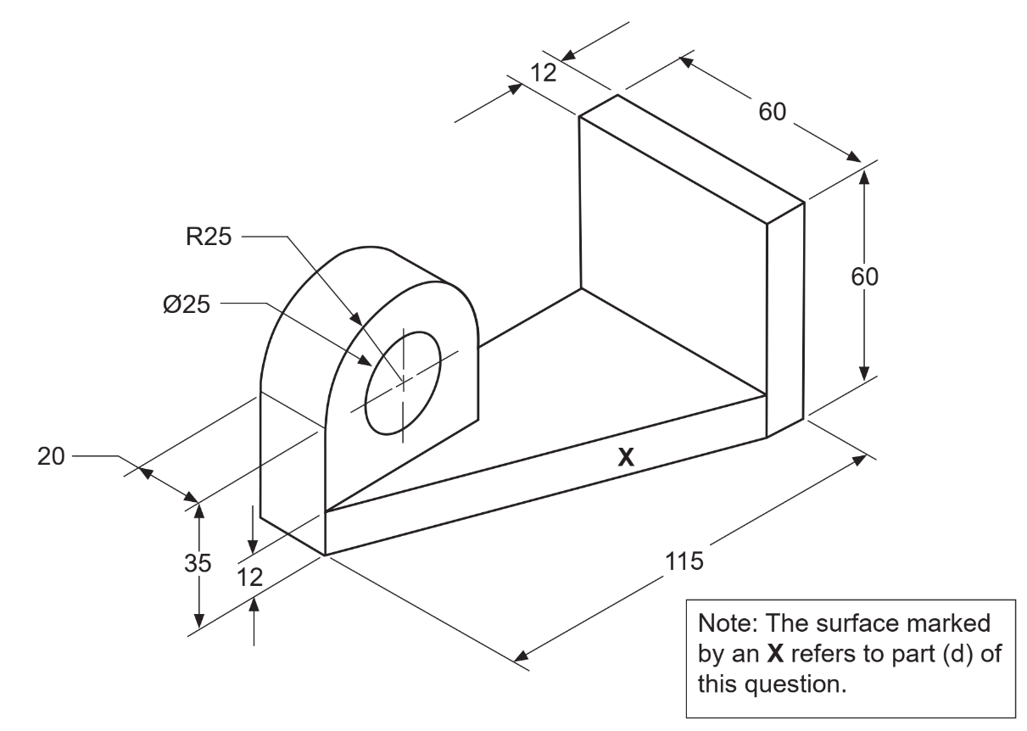

(School Curriculum and Standards Authority of Western Australia, 2020)

$$l^{2}={40}^{2}+{103}^{2}$$

$$l=110.49$$

$$A=12×110.49=1325.93$$

1. **Write a formula that could be used to find the surface area of cube of width ‘w’, with a cylindrical hole of radius ‘r’ passing through it.**

$A=w^{3}-2πr^{2}+2πrw$

## **Electrical/electronics**

#### Component symbols and descriptions

You must be familiar with the symbols for, and general characteristics of the components listed in the syllabus. The symbols can be found on the datasheet.

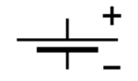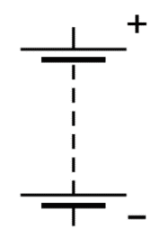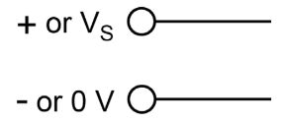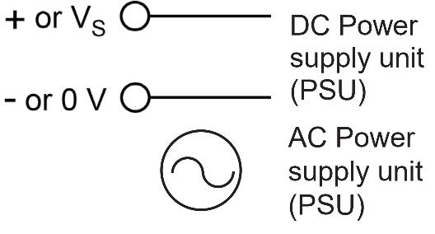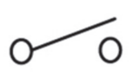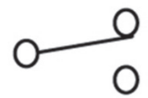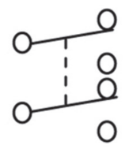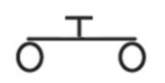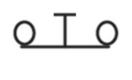

cell: DC power supply, uses a chemical reaction to create a voltage between the two terminals

battery: DC power supply, multiple cells connected in series provide the sum of each of their voltages

DC power supply unit: two terminals of a device that supplies DC voltage, e.g., power pack

AC power supply unit: device that supplies AC voltage, e.g., power pack

SPST switch: single pole, single throw, one switch, one position completes the circuit

SPDT: single pole, double throw, one switch, two positions complete circuits

DPDT: double pole, double throw, two switch, two positions complete circuits

Push to make: switch, off unless pushed

Push to break: switch, on unless pushed

fuse: safety device, functions as normal wire unless current gets too high, e.g., from short circuit, then breaks preventing fire

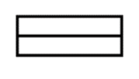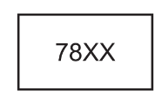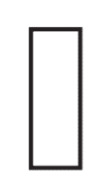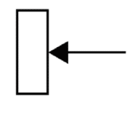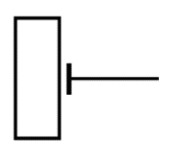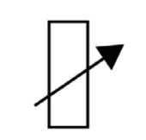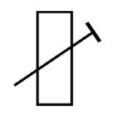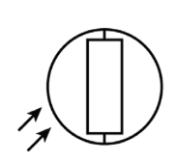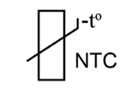

78XX voltage regulator: produces fixed positive voltage of XX volts, has 3 pins; input, ground and output, wastes excess energy as heat

resistor: converts some energy to heat, reduces voltage across other components in series

potentiometer: voltage divider used to supply an adjustable fraction of the external voltage to another device, can be used as a variable resistor

preset potentiometer: potentiometer calibrated by manufacturer to a certain value, not intended for adjustment by consumer

variable resistor: resistor with variable resistance

preset variable resistor: variable resistor calibrated by manufacturer to a certain value, not intended for adjustment by consumer

light-dependent resistor: resistor with resistance dependent on incident light

thermistor (NTC): resistor which decreases resistance significantly as temperature increases

non-polarized capacitor: stores charge/energy when exposed to a voltage, will not allow DC to flow through it but can effectively allow AC through, e.g., film or ceramic capacitors

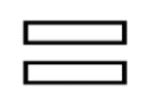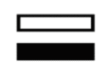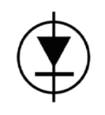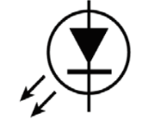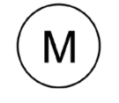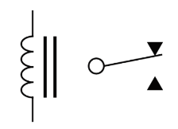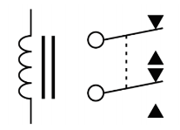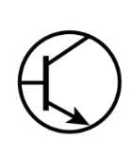

polarized capacitor: stores charge/energy when exposed to a voltage in the right direction (DC only), will not allow current to flow through it, e.g., electrolytic capacitors

diode: device that allows current to flow in only one direction, can be used in a “rectifier” converting AC to DC, arrow in symbol shows direction of conventional current

LED: diode that converts electrical energy to light energy very efficiently when current flows

bulbs/lamps: converts electrical energy to light and heat (symbol not on datasheet)

DC motor: converts electrical energy from DC to kinetic energy

SPDT relay: electrically operated switch, one switch, two positions complete circuits

DPDT relay: electrically operated switch, two switches, two positions complete circuits

NPN transistor: can function as a switch with a current at one terminal (base) controlling current through the other two or as an amplifier with a small current in one terminal (base) allowing a larger current through the other two

integrated circuit (generic): set of circuits printed as one small chip, smaller faster and cheaper than building a circuit from individual

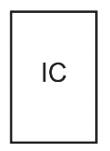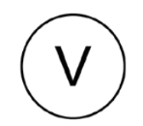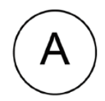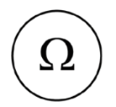

voltmeter: measures the voltage between two points in a circuit, e.g., the voltage supplied by a power supply, or the voltage used by another component

ammeter: measures the current through a point in a circuit

ohmmeter: measures the resistance between two points in a circuit

The two components below are on the datasheet but not listed in the syllabus.

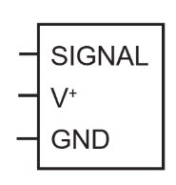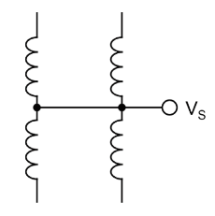

servo motor: creates rotational or linear motion with precise control of position, velocity and acceleration, has three pins: control, power, and ground

unipolar stepper motor: steps through a number of positions through a full rotation, generally cheaper and easier to control than servo motors

#### Applying component markings

**Resistors**

Fixed value resistors are labelled with coloured bands to show their resistance. You must be able to interpret these bands to determine the resistance of a given resistor. The data book includes the table below.

**Capacitors**

Capacitance is a measure of the amount of energy a capacitor can store, its units are Farads (F). Capacitors typically have capacitances measured in μF, nF or pF.

The capacitance can be written on the capacitor:

* in full, e.g., 24 μF
* just with the prefix, e.g., 24μ
* just with three numbers, XYZ where C=XYx10Z in pF, e.g., 246 = 24 x106 pF = 24 μF

(a letter may be added after the three numbers to denote the tolerance of the value but this is not needed for this course)

**Voltage regulator pin out**

**78XX**

1

3

2

|  |  |  |
| --- | --- | --- |
| Pin no. | Pin | Function |
| 1 | Input | unregulated voltage input up to ~40 V |
| 2 | Ground | grounded (0 V) |
| 3 | Output | regulated output of XX V |

**Transistor pin out**

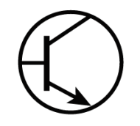

b

c

e

|  |  |  |
| --- | --- | --- |
| Pin no. | Pin | Function |
| b | Base | controlling current input |
| c | Collector | controlled current input |
| e | Emitter | controlled current output |

**Integrated circuit pin outs**

In integrated circuits, the pins are numbered anticlockwise from the top left corner. Way up can be identified by the writing on the chip, marking spots or notches.

E.g., in the chip below, IN3 is pin 18.

#### Diagram Description automatically generatedPractice problems

1. The purpose of the circuit to the side is to:
   1. produce a sine wave output
   2. change the direction of the input current
   3. protect from reverse polarity
   4. produce a DC output

(School Curriculum and Standards Authority of Western Australia, 2016)

1. Explain the significance of the phrase “negative thermal coefficient” in relation to a thermistor

Most devices increase in resistance as temperature increases, NTC thermistors are the opposite, they decrease in resistance as temperature increases

1. Complete the table below

|  |  |  |  |
| --- | --- | --- | --- |
| **Component** | **Marking** | **Value** | **Unit** |
| Fixed value resistor | yellow, violet, green | 4 700 000 | Ω |
| Polyester capacitor | 223 | 22x103 | pF |

1. Complete the table below for a 68 Ω, 5% tolerance, 1 W resistor

|  |  |  |  |  |  |
| --- | --- | --- | --- | --- | --- |
| **Band 1 colour** | **Band 2 colour** | **Band 3 colour** | **Band 4 colour** | **Maximum value** | **Minimum value** |
| blue | grey | black | gold | 71.4 | 64.6 |

1. What would be a label on a 150 pF capacitor? 151, 150p or 150pF
2. A 3 pin IC marked with the symbol 7805 is a:
   1. microcontroller chip.
   2. 5 V voltage regulator.
   3. NPN transistor.
   4. 7805 Ω variable resistor
3. Which component is suitable for each of the following:
   1. a temperature sensor NTC thermistor
   2. a light sensor light-dependent resistor
   3. allowing AC but blocking DC capacitor
   4. allowing DC but blocking AC diode
4. Which of the following components is not polarity sensitive?
   1. light-dependent resistor
   2. semiconductor diode
   3. electrolytic capacitor
   4. light emitting diode
5. Sketch and label a circuit diagram that meets the following specifications
   1. Power supply is three 1.5 V cells connected in series.
   2. A SPST switch (SW) when closed will cause a bulb (L), to glow and when open the bulb will cease to glow.

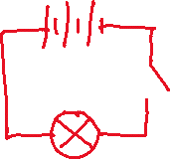

1. Sketch and label a circuit diagram that meets the following specifications
   1. Power supply is a 6 V battery.
   2. The circuit incorporates two bulbs (L1 and L2).
   3. A SPDT switch (SW) when thrown to the normally closed (N/C) terminal will cause one of the bulbs to glow while the other is off.
   4. When the switch is thrown to the normally open (N/O) terminal then the bulbs will behave in the opposite manner.

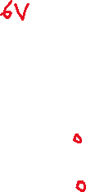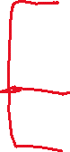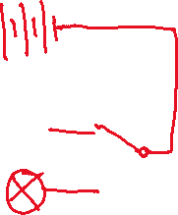

1. Sketch and label a circuit diagram that meets the following specifications
   1. Power supply is a 12 V battery.
   2. The circuit incorporates four (4) push to break switches, SW1 - SW4, and a bulb, L.
   3. Any single closed switch or combination of closed switches can turn the bulb on but all four (4) must be pressed to the open position for the bulb to turn off.

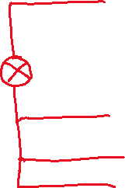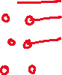

1. Sketch and label a circuit diagram that meets the following specifications
   1. Power supply is 12 V AC.
   2. Two (2) SPDT switches, SW1 and SW2, control a single bulb, L.
   3. Either switch can turn the bulb on and off without having to adjust the other switch.

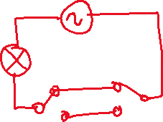

#### Laws and principles

In electrical circuits there are several quantities of interest:

**Potential difference/electromotive force (emf)/voltage (V)**

* measured in volts (V)
* a measure of the difference in electric potential energy between two points in a circuit.

**Current (I)**

* measured in amperes (A)
* the rate of flow of electric charge past a point in a circuit.

**Resistance (R)**

* measured in ohms (Ω)
* a measure of the opposition to flow of charge through part of a circuit.

**Power (P)**

* measured in watts (W)
* the rate of use/transfer/transformation of energy.

**Capacitance (C)**

* measured in farads (F)
* a measure of a capacitors ability to store energy.

#### Measuring voltage, current and resistance

Voltmeters are connected in parallel to a component or number of components to measure the voltage or potential difference or voltage across the component(s). A perfect theoretical voltmeter has infinite resistance so allows no current to flow through it.

**V**

Ammeters are connected in series with a component to measure the current through the component. A perfect theoretical ammeter has zero resistance so does not use any voltage.

**A**

Ohmmeters are connected in parallel to a component or number of components to measure the resistance of the component(s). They must be used a circuit that is not live.

Ω

**Ohm’s Law**

The fundamental relationship between voltage, current, and resistance. A voltage causes current to flow, proportional to the voltage and inversely proportional to the resistance.

$$V=IR$$

**Kirchoff’s Current Law**

The total current entering a junction must equal the total current exiting a junction.

$$\sum{I}=0$$

**Kirchoff’s Voltage Law**

The total voltage supplied by a circuit must equal the total voltage used by a circuit.

$$\sum{∆V}=0$$

**Behaviour of voltage and current in complex circuits**

* Voltage divides between components in series, proportional to their resistance.
* Parallel paths receive the same voltage.
* All components in series receive the same current.
* Current divides between parallel paths inversely proportional to their resistance.

The formulae below are also available in the data book:

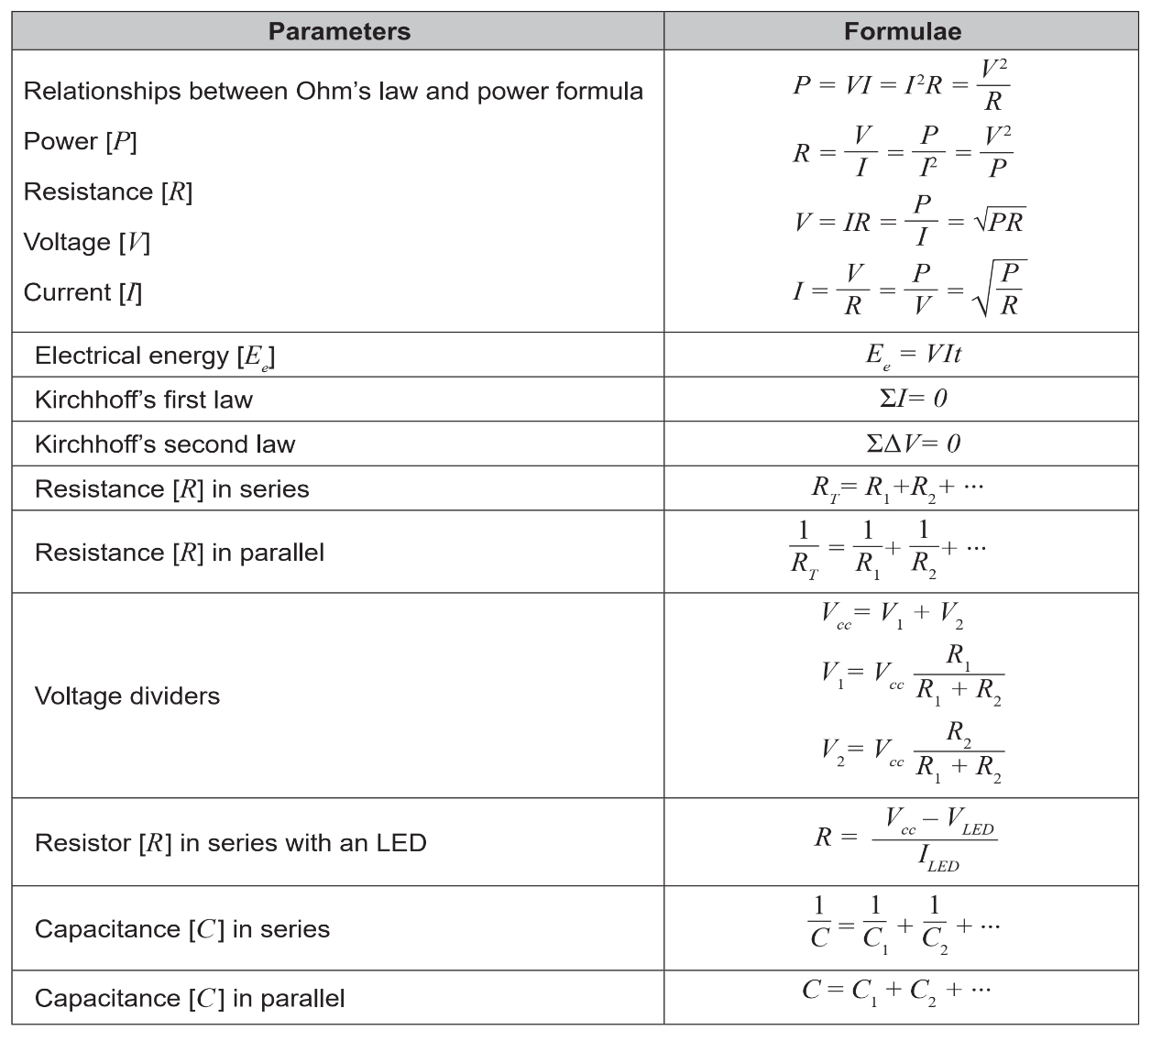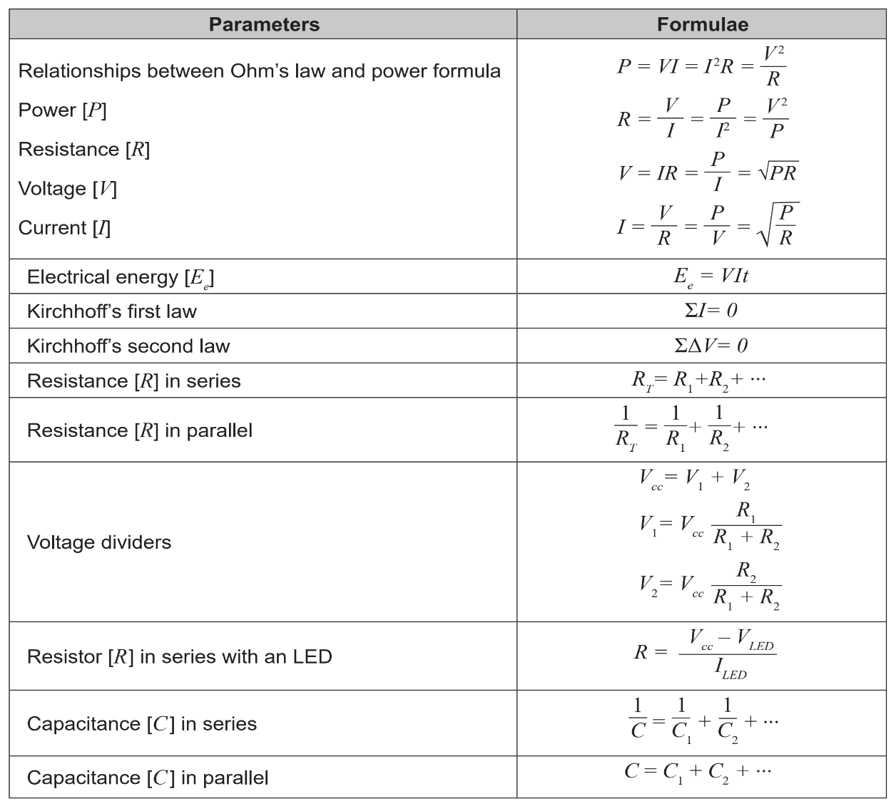

**You must also be comfortable handling unit conversions with the SI prefixes found in the data book:**

**Practice problems**

1. **The current I3 in the following circuit is**
   1. **-8 A**
   2. **2 A**
   3. **-2 A**
   4. **8 A**

(School Curriculum and Standards Authority of Western Australia, 2016)

1. **Complete the following table for each component.**

|  |  |  |  |  |
| --- | --- | --- | --- | --- |
| ****Component**** | ****Power**** | ****Voltage**** | ****Current**** | ****Resistance**** |
| **Component 1** | **4.4 mW** | **0.0727 V** | **0.0606 A** | **1.2 Ω** |
| **Component 2** | **20 kW** | **440 V** | **45.45 A** | **9.68 Ω** |

1. **Referring to the circuit below:**

(School Curriculum and Standards Authority of Western Australia, 2016)

* 1. **Calculate the resistance between A and C. 600 Ω**
  2. **Calculate the total resistance. 360 Ω**
  3. **Find the current at E. 0.025 A**
  4. **Find the current through the 270 Ω resistor. 0.01 A**
  5. **Find the current through the 220 Ω resistor. 0.015 A**
  6. **Find the power dissipated in the 330 Ω resistor. 0.033 W**
  7. **Find the potential difference between B and D. 0 V**

1. **Two resistors are connected in parallel. The first has a value of 1.2 kΩ. The combined value of the two resistors in 300 Ω. Determine the value of the other resistor.**

**400 Ω**

1. **A 24 V battery is connected to the circuit as shown below. The current flowing from the battery is 3A and the current flowing through R1 is 1.8 A.**

(School Curriculum and Standard Authority of Western Australia, 2017)

* 1. **What is the current through the 5 Ω resistor? Give a reason why. 1.8 A because it is in series with the 1.8 A marked and the current through the voltmeter will be 0**
  2. **Calculate the current through the 12 Ω resistor.**

**1.2 A**

* 1. **Show by calculation the potential difference displayed on the voltmeter.**
 $$V_{12}=1.2×12=14.4 V$$

 2. **Calculate the power dissipated in the 5 Ω resistor. 16.2 W**
  3. **Calculate the value of resistor R1. 3 Ω**
  4. **Calculate the value of resistor R2. 3.2 Ω**
  5. **If the voltage of the 24 V battery was to drop to 19.6 V, calculate the new reading on the voltmeter. 11.76 V**

1. **The circuit below is that of a battery pack made from two 4.5 V cells.**

(School Curriculum and Standards Authority of Western Australia, 2018)

* 1. **Calculate the voltage and current capacity of this battery pack at the outputs AB.**

**9 V, 2 A**

1. **A second battery pack is made using three cells. Two of these are 4.5 V cells, with a third cell to be added between the points A and B as shown below.**

(School Curriculum and Standards Authority of Western Australia, 2018)

* 1. **Determine the voltage and current capacity this cell would need to have so that this battery pack could supply 6 A at 4.5 V to the load?**

**4.5 V, 1 A**

1. **Calculate the total capacitance across AB in the circuit below. 7.26 µF**



(School Curriculum and Standards Authority of Western Australia, 2018)

1. **Calculate the value of the capacitor required to bring the total capacitance between A and B in the circuit above to 10 μF and correctly draw it into the circuit in q8. 2.74 µF**
2. **Examine the circuit diagram below and calculate the following:**

* 1. **IR1 0.033 A**
  2. **IR3 0.017 A**
  3. **PR2 0.033 W**

1. **Examine the circuit diagram below and calculate the following:**

* 1. **IR2 0.0118 A**
  2. **VR1** 2.59 V
  3. **VR4 0.88 V**
  4. **PR3 0.0052 W**

1. **Examine the circuit diagram below and calculate the following:**

* 1. **VR5 0.658 V**
  2. **IR3 0.0301 A**
  3. **PR4 0.0413 W**

1. **Examine the circuit diagram below and calculate the following:**

* 1. **RT (assume R3 = 100 Ω) 43.57 Ω**
  2. **IS 0.138 A**
  3. **PT 0.826 W**
  4. **Node voltage VC (voltage from node C to 0 V) 3.93 V**
  5. **Node voltage VD (voltage from node D to 0 V) 2.95 V**

1. **Examine the circuit diagram below and complete the following table:**

|  |  |  |  |
| --- | --- | --- | --- |
| **When the switch is closed** | | | |
| **Circuit Element** | **Voltage (V)** | **Current (A)** | **Power (W)** |
| *V*S1 | *V*S1 = 4.5 | 0.02 | *P*S1 = 0.09 |
| *V*S2 | *V*S2 = 3.0 | 0.023 | *P*S2 = 0.069 |
| *R* 1 | 4.5 | 0.009 | 0.0405 |
| *R* 2 | 3 | 0.012 | 0.036 |
| *R* 3 | 7.5 | 0.011 | 0.0825 |

1. **Examine the circuit diagram below and complete the following table:**

|  |  |  |  |
| --- | --- | --- | --- |
| **When the switch is open** | | | |
| **Circuit Element** | **Voltage (V)** | **Current (A)** | **Power (W)** |
| *V*S1 | *V*S1 = 4.5 | 0.021 | *P*S1 = 0.0945 |
| *V*S2 | *V*S2 = 3.0 | 0.021 | 0.063 |
| *R* 1 | 5 | 0.01 | *P*R1 = 0.05 |
| *R* 2 | 2.5 | 0.01 | 0.025 |
| *R* 3 | 7.5 | 0.011 | 0.0825 |

## **Systems and control**

#### Nature of control systems

Systems take one or more inputs through processes to create one or more outputs.

This can be shown by a universal system block diagram:

Process

Input

Output

For a toaster it would be:

Toaster

Electrical energy  
Bread

Switch on

Toast

Waste heat

These diagrams lack detail so sub-system diagrams can be used to show functional relationships between the components of a control system.

A generic subsystem diagram is shown below:

Controller

Input/set point

Output

Plant   
command

Plant

For a toaster it would be:

Timer on

Electrical energy

Bread

Switch on

Toast

Waste heat

Current

Heating element

This is an example of an open loop system there is no monitoring and feedback of the output. Open-loop systems are simple, cheap and stable but they are unreliable and cannot account for external disturbances.

A toaster uses an open loop control system, the user sets the number on the dial (input), the controller turns on the heating element (plant) for an amount of time based on the input.

This will produce good toast if the user knows the toaster well and chooses the right setting, but it will not perform well for an unfamiliar user or if there is a disturbance such as the bread being frozen.

A typical closed loop control system is shown below:

**+**

**-**

Feedback element

Input/set point

Controller

Plant

Feedback signal

Disturbance

Error   
signal

Plant command

Output

In a closed loop system, the output is monitored and fed back through the controller to achieve more accurate results and cope with external disturbances. This is an example of negative feedback, if the output is different from the set point, the system changes in the opposite direction in an attempt to match the output to the set point.

Generally negative feedback will oppose change, or deviation from the desired value, while positive feedback will enhance change or deviation from the initial value. Positive feedback is less commonly useful in control systems.

Cruise control in a car is a closed loop. The user sets the desired speed (input) which is passed to a summing point. The feedback element monitors the current speed (output) and feeds it back to the summing point. The summing point acts as an error sensor, it calculates the difference between the desired speed and the current speed and sends the result as an error value to the controller which adjusts the mechanics of the car (plant) to move towards the desired speed.

This is more likely to produce the correct output than a simple open loop and can account for external disturbances, but it is much more complicated and costly and can even be unstable if poorly implemented.

The instability possible in closed loops comes from the system overcorrecting for an error, creating an even larger error in the opposite direction which can rapidly get out of control if it repeats.

#### Practice problems

1. Classify each of the following as either open loop or closed loop
   1. Timer based clothes drier open
   2. Stove top kettle open
   3. Electric kettle closed
   4. Microwave oven open
   5. Volume of radio open
   6. Air conditioner with thermostat closed

#### Logic Gates

**Logic gates perform a logical operation (known as a Boolean function) on one or more binary inputs to produce a single binary output.**

****NOT****

**Output is the opposite of the input**

**Boolean expression: $\overline{A}$**

Truth table:

|  |  |
| --- | --- |
| **Input** | **Output** |
| A | NOT A |
| 0 | 1 |
| 1 | 0 |

****AND****

Only returns on output if both inputs are on

Boolean expression: $A.B$

**Truth table:**

|  |  |  |
| --- | --- | --- |
| **Input** | | **Output** |
| A | B | A AND B |
| 0 | 0 | 0 |
| 0 | 1 | 0 |
| 1 | 0 | 0 |
| 1 | 1 | 1 |

****NAND (NOT AND)****

Returns on output unless both inputs are on

Boolean expression: $\overline{A.B}$

Truth table:

|  |  |  |
| --- | --- | --- |
| **Input** | | **Output** |
| A | B | A NAND B |
| 0 | 0 | 1 |
| 0 | 1 | 1 |
| 1 | 0 | 1 |
| 1 | 1 | 0 |

****OR****

Returns on output if either (or both) inputs are on

Boolean expression: $A+B$

Truth table:

|  |  |  |
| --- | --- | --- |
| **Input** | | **Output** |
| A | B | A OR B |
| 0 | 0 | 0 |
| 0 | 1 | 1 |
| 1 | 0 | 1 |
| 1 | 1 | 1 |

****NOR (NOT OR)****

Returns on output if neither input is on

Boolean expression: $\overline{A+B}$

Truth table:

|  |  |  |
| --- | --- | --- |
| **Input** | | **Output** |
| A | B | A OR B |
| 0 | 0 | 1 |
| 0 | 1 | 0 |
| 1 | 0 | 0 |
| 1 | 1 | 0 |

****XOR (eXclusive OR)****

Returns on output if either (NOT both) inputs are on

Boolean expression: $A\text{⊕}B$

|  |  |  |
| --- | --- | --- |
| **Input** | | **Output** |
| A | B | A OR B |
| 0 | 0 | 0 |
| 0 | 1 | 1 |
| 1 | 0 | 1 |
| 1 | 1 | 0 |

#### **Combinational logic diagrams**

All our logic gates only have two inputs, can combine them to handle more complex situations, will deal with up to 3 inputs

E.g., a bank wants an alarm, triggered by motion sensors in three rooms, design a combinational logic diagram that will return an on result if any of the three inputs are on.   
Draw the diagram, produce a truth table and a Boolean logic expression for the   
diagram.

**(A+B)+C**

|  |  |  |  |
| --- | --- | --- | --- |
| **Input** | | | **Output** |
| **A** | **B** | **C** | **(A OR B) OR C** |
| 0 | 0 | 0 | 0 |
| 0 | 0 | 1 | 1 |
| 0 | 1 | 0 | 1 |
| 0 | 1 | 1 | 1 |
| 1 | 0 | 0 | 1 |
| 1 | 0 | 1 | 1 |
| 1 | 1 | 0 | 1 |
| 1 | 1 | 1 | 1 |

The previous alarm triggered too many false alarms so they want it to only trigger if two or more of the three motion sensors detect something, design a new combinational logic diagram that will return an on result if any two of the three inputs are on.   
Draw the diagram, produce a truth table and a Boolean logic expression for the   
diagram.

**(AB+AC)+BC**

|  |  |  |  |
| --- | --- | --- | --- |
| **Input** | | | **Output** |
| **A** | **B** | **C** | **((A AND B) OR (A and C)) OR (B AND C)** |
| 0 | 0 | 0 | 0 |
| 0 | 0 | 1 | 0 |
| 0 | 1 | 0 | 0 |
| 0 | 1 | 1 | 1 |
| 1 | 0 | 0 | 1 |
| 1 | 0 | 1 | 1 |
| 1 | 1 | 0 | 1 |
| 1 | 1 | 1 | 1 |

Design a combinational logic diagram for a setup that will ring a buzzer when the car door is open, or the key is in the ignition without the seatbelt done up. Include a Boolean logic expression and truth table with your answer.

**D+KS**

|  |  |  |  |
| --- | --- | --- | --- |
| **Input** | | | **Output** |
| **D**  **1=open** | **K**  **1=in** | **S**  **1=undone** | **D OR (K AND S)** |
| 0 | 0 | 0 | 0 |
| 0 | 0 | 1 | 0 |
| 0 | 1 | 0 | 0 |
| 0 | 1 | 1 | 1 |
| 1 | 0 | 0 | 1 |
| 1 | 0 | 1 | 1 |
| 1 | 1 | 0 | 1 |
| 1 | 1 | 1 | 1 |

# References

Munroe, R. (2007, Decmber 12). *Nerd Sniping*. Retrieved from xkcd: https://xkcd.com/356/

*Oblique projection*. (n.d.). Retrieved from Wikipedia: https://en.wikipedia.org/wiki/Oblique_projection

School Curriculum and Standard Authority of Western Australia. (2017). *Engineering Studies.* Retrieved from School Curriculum and Standard Authority: https://senior-secondary.scsa.wa.edu.au/syllabus-and-support-materials/technologies/engineering-studies

School Curriculum and Standards Authority of Western Australia. (2016). *Engineering Studies.* Retrieved from School Curriculum and Standards Authority: https://senior-secondary.scsa.wa.edu.au/syllabus-and-support-materials/technologies/engineering-studies

School Curriculum and Standards Authority of Western Australia. (2018). *Engineering Studies.* Retrieved from School Curriculum and Standards Authority: https://senior-secondary.scsa.wa.edu.au/syllabus-and-support-materials/technologies/engineering-studies

School Curriculum and Standards Authority of Western Australia. (2019). *Engineering Studies.* Retrieved from School Curriculum and Standards Authority: https://senior-secondary.scsa.wa.edu.au/syllabus-and-support-materials/technologies/engineering-studies

School Curriculum and Standards Authority of Western Australia. (2020). *Engineering Studies.* Retrieved from School Curriculum and Standards Authority: https://senior-secondary.scsa.wa.edu.au/syllabus-and-support-materials/technologies/engineering-studies